SOUTHGATE WARD FORUM
Tuesday 15th October, 7.30pm – 9.00pm

The Southgate Club
17 Chase Side
(use Crown Lane entrance)
Southgate
London N14 5BP
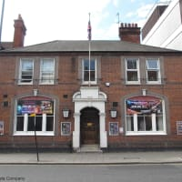
Please

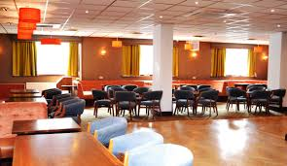
Your chance to come and meet your local Ward Councillors and tell them what matters to you in Southgate Ward
Cllr.Charith.Gunawardena Cllr.Stephanos.Ioannou Cllr.Derek.Levy
@enfield.gov.uk @enfield.gov.uk @enfield.gov.uk
Tel: 020 8379 3012/07971 672619 Tel: 020 8379 8457/07971 672565 Tel: 020 8379 1741/07812 673107
Working for a better Southgate …
We hold our weekly surgeries every Saturday morning at St Andrew’s Church, Chase Side, Southgate (by ASDA) and at
The Alan Pullinger Centre, John Bradshaw Road, (off Southgate High Street)
No appointment is required

